Style Guidelines for Final Year Project ReportsAI-Powered Virtual Medical Assistant and Smart Doctor Calling Agent
Final Year Project
Session 2022-2026

A project submitted in partial fulfillment of the requirements for the Degree
of
BSc. (Hons.)BS in Computer Science



Authors
Muhammad Aatir (UET/22-CS-09)
Mudassir Rizwan (UET/22-CS-30)
Shariq Mateen (UET/22-CS-96)

Supervised By
Dr. Syed Aun Irtaza
Associate Professor (HOD)

Department of Computer Science
University of Engineering and Technology Taxila, Taxila
Project Details
Project ID (for office use)
Type of project | Traditional Industrial
Nature of the project | Development Research & Development
Sustainable Development Goals(SDGs) | Food Security Sustainable Energy & Water  Climate Change and Environment No Poverty and Zero Hunger  Good Health and Well-Being Quality Education  Gender Equality Industry, Innovation, & Infrastructure  Decent Work and Economic Growth Life on Land & Water
Area of specialization | Artificial Intelligence (AI) Blockchain Technology  Cybersecurity Data Science and Analytics  Game Development Internet of Things (IoT)  Natural Language Processing (NLP) Computer Vision & Image Processing  Web Development Mobile App Development  Robotics Health Informatics
FYP Committee
Dr. Syed Adnan Shah | Dr. Qamas Gul Khan Safi
Dr. Rao Wakeel Ahmad | Mrs Asima Ismail
Dr. Farooq Ali

Acceptance Certificate
This is to certify that the Final Year Project titled AI-Powered Virtual Medical Assistant and Smart Doctor Calling Agent submitted by Muhammad Aatir (UET/22-CS-09), Mudassir Rizwan (UET/22-CS-30), and Shariq Mateen (UET/22-CS-96), has been reviewed, examined, and accepted as satisfactorily fulfilling the academic requirements of the Bachelor's program in Computer Science at UET Taxila.
The work has been found complete and presented in accordance with departmental standards & guidelines.

Name & Signature:______________________
Supervisor

Name & Signature:______________________
External Examiner

Name & Signature:______________________
Head of the Department

ABSTRACT
Intelligent virtual assistants and automation systems have provided new opportunities for healthcare to improve patient engagement, decision-making, and operational efficiency through the implementation of artificial intelligence. Conversational agents powered by AI are being deployed more frequently to provide primary medical advice, symptom data analysis, and medical accessibility, specifically in telemedicine and digital health systems. These kinds of technology can be very instrumental in weakening the communication barriers and improving the delivery of health services. Although this progress has occurred, patients still find it difficult to properly explain their symptoms and the right medical expert with whom to consult. Moreover, physicians and clinics have administrative difficulties with patient calls, appointments, and other routine inquiries being carried out manually, creating overload, delays, and ineffective utilization of medical facilities. In a bid to help overcome these issues, this project suggests that the problems can be overcome with an AI-Powered Virtual Medical Assistant and Smart Doctor Calling Agent, which will engage with patients in an intelligent, conversational manner. The system uses machine learning to analyze patient-repeatedly reported symptoms and prescribes appropriate doctors on the ground and location, automates the process of call handling and appointment management by doctors using voice-based AI agents. The offered system should enhance the efficiency of healthcare communication, ease the work of medical professionals, and help the patient to make informed choices on the topic of their healthcare requirements. Finally, the project will have an objective of improving accessibility, responsiveness, and the general quality of healthcare services through smart automation.

Author’s Biographical Sketch

 | Muhammad Aatir (UET/22-CS-09) is a specialist in the field of AI and machine learning, focusing on developing AI agents, intelligent automation, and optimization of the workflow. He has worked a lot to create real-world AI and develop agentic systems to simplify the complex processes using OpenAI, n8n, and Google Cloud. He has acquired several machine learning, deep learning, and AI automation certifications at IBM, Coursera, and Google Cloud. Muhammad has managed to develop such projects as automation of customer support using AI, plant disease detection based on computer-based vision, a calling agent, and real estate lead management systems. He loves using the latest technology to find answers to real-world problems and likes working on projects related to AI that are more innovative, and wants to carry them through to the end by using the available technology and implementing creativity.
 | Mudassir Rizwan (UET/22-CS-30) is a Frontend and Web Application Developer skilled in the creation of responsive, user-friendly, and modern Web Interfaces. He has a vast range of experience in the field of web app development to create user interfaces that are intuitive and scalable. Mudassir helped in creating patient, doctor, and administrator dashboards in this project and provided a smooth navigation, access, and similar experience between various devices. Besides frontend development, he also has practical experience with agent-based AI systems, as well as workflow automation, during which he has worked on both the integration of AI-based features and the automation of workflows with modern automation frameworks. He has worked in partnership with the back-end and AI elements to make sure that there is smooth interaction among user interfaces, intelligent agents, and automated processes. Mudassir loves creating intelligent and interactive applications, which integrate good user experience with AI functionality in solving real challenges in the real world.
 | Shariq Mateen (UET/22-CS-96), who is a data and AI expert, specializes in creating intelligent processes and automating AI, as well as data analysis. He has practised a lot in the design of effective data systems and the creation of AI agents based on OpenAI, Gemini, and n8n. Shariq has worked with SQL databases, ETL pipelines, and developed insightful dashboards using Excel, Power BI, and Tableau. He is a multiple AI and Data scholar from IBM and Coursera, which reinforces his professional knowledge in this direction. Shariq likes using the newest AI and data technologies to address the real life issues and simplify complicated processes.
Acknowledgement
We would like to thank Dr. Syed Aun Irtaza, who is our project supervisor, as he guided and supported us during the whole process of the project development, as well as provided feedback that enabled the project to attain this status. His experience and support were very crucial in directing the successful execution of our work.
Another aspect we are grateful to the Department of Computer Science, University of Engineering and Technology Taxila, which has the resources, learning environment, and academic support needed. Lastly, we would like to mention our families and friends who provided constant motivation and moral encouragement in the course of preparing this report.

Dedication
To our parents, families, and teachers,
Whose constant support, prayers, guidance, and encouragement have been the foundation of our academic journey and the successful completion of this project.
Declaration Certificate
We certify that the Final Year Project titled "AI-Powered Virtual Medical Assistant and Smart Doctor Calling Agent" submitted to the Department of Computer Science, UET Taxila, is our original work, developed in accordance with academic standards and HEC guidelines. The plagiarism similarity index is 16%, within the acceptable limit of 20% (report attached as Appendix A). All external sources have been properly cited. We affirm the originality of this work and accept full responsibility for any future plagiarism claims.

Author Signatures:

Name: Muhammad Aatir Signature:______________________
Registration No.: 22-CS-09

Name: Mudassir Rizwan Signature:______________________
Registration No.: 22-CS-30

Name: Shariq Mateen Signature:______________________
Registration No.: 22-CS-96

Table of Contents
Chapter 1. Introduction 14
1.1 Introduction 14
1.2 Problem Statement 15
1.3 Proposed Solution 16
1.4 Main Objectives 16
1.5 Assumptions & Constraints 16
1.6 Project scope 16
1.7 Software Development Lifecycle Model 16
Chapter 2. Existing Solutions 18
2.1 Selection Criteria for Solutions 18
2.2 Solution 1: Ada Health 18
2.2.1 Overview 18
2.2.2 Key Features & Functions 18
2.2.3 Technology Stack 20
2.2.4 User Interface & Experience 20
2.2.5 Strengths 20
2.2.6 Drawbacks/Limitations 20
2.2.7 Target Audience 20
2.3 Solution 2: Babylon Health 20
2.3.1 Overview 20
2.3.2 Key Features & Functions 20
2.3.3 Technology Stack 22
2.3.4 User Interface & Experience 22
2.3.5 Strengths 22
2.3.6 Drawbacks / Limitations 22
2.3.7 Target Audience 22
2.4 Solution 3: WebMD 22
2.4.1 Overview 22
2.4.2 Key Features & Functions 22
2.4.3 Technology Stack 25
2.4.4 User Interface & Experience 25
2.4.5 Strengths 25
2.4.6 Drawbacks / Limitations 25
2.4.7 Target Audience 25
2.5 Solution 4: Practo 25
2.5.1 Overview 25
2.5.2 Key Features & Functions 25
2.5.3 Technology Stack 27
2.5.4 User Interface & Experience 27
2.5.5 Strengths 27
2.5.6 Drawbacks / Limitations 27
2.5.7 Target Audience 27
2.6 Solution 5: Doctolib 27
2.6.1 Overview 27
2.6.2 Key Features & Functions 27
2.6.3 Technology Stack 29
2.6.4 User Interface & Experience 29
2.6.5 Strengths 29
2.6.6 Drawbacks / Limitations 29
2.6.7 Target Audience 29
2.7 Solution 7: Marham 29
2.7.1 Overview 29
2.7.2 Key Features & Functions 29
2.7.3 Technology Stack 32
2.7.4 User Interface & Experience 32
2.7.5 Strengths 32
2.7.6 Drawbacks / Limitations 32
2.7.7 Target Audience 32
2.8 Comparative Analysis Table 33
2.9 Identified Gaps & Project Justification 33
Chapter 3. Requirement Analysis 34
3.1 Stakeholders List 34
3.2 Requirements Elicitation 34
3.2.1 Functional Requirements 34
3.2.2 Non-functional Requirements 35
3.2.3 Requirements Traceability Matrix 35
3.3 Use Case Description 36
3.4 System Constraints and Assumptions 36
Chapter 4. System Design 37
4.1 Use Case Design 37
4.2 Activity Diagram 38
4.3 Sequence Diagram 39
4.4 Software Architecture Diagram 40
4.5 Class Diagram 41
4.6 Database Diagram 42
4.7 Collaboration Diagram 43
Chapter 5. References 44

List of Tables
Table 2.1. Comparative analysis of existing digital healthcare platforms 33
Table 3.1. Requirements Traceability Matrix 35

List of Figures
Figure 2.1. Interactive symptom & medical history questions 19
Figure 2.2. Personalized health articles & advice 19
Figure 2.3. Symptom search and detailed selection 19
Figure 2.4. Online appointment scheduling with calendar and time zone selection 21
Figure 2.5. Programme booking for personalized family health coaching 21
Figure 2.6. Symptom entry with search suggestions and interactive body map 23
Figure 2.7. Potential condition suggestions with match ratings 23
Figure 2.8. Medical articles, condition guides, and treatment details 24
Figure 2.9. Physician directory with search filters, ratings, and virtual visit options 24
Figure 2.10. Online video/audio consultation promotion with instant doctor access and digital features 26
Figure 2.11. Location-based doctor search by specialization (e.g., kids dentist in Dubai) with filters and booking options 26
Figure 2.12. Online appointment booking interface with consultation type selection and real-time date availability 28
Figure 2.13. Advanced doctor search by specialty/location with calendar previews and availability slots 28
Figure 2.14. Doctor discovery feature on Marham for finding sports medicine specialists 30
Figure 2.15. The medicine search feature on Marham shows available Panadol options 30
Figure 2.16. Health articles and wellness information feature on Marham, providing diet, nutrition, skincare, and lifestyle guidance. 31
Figure 2.17. Ask Pakistani doctors real questions & consult online from home 31
Figure 4.1. Use Case Diagram of the AI-Powered Virtual Medical Assistant System 37
Figure 4.2. Activity Diagram representing patient and doctor interactions 38
Figure 4.3. Sequence Diagram illustrating symptom analysis and doctor recommendation workflow 39
Figure 4.4. Software Architecture Diagram of the AI-Powered Medical Assistant System 40
Figure 4.5. Class Diagram showing system entities and relationships 41
Figure 4.6. Database (ER) Diagram of the Medical Assistant System 42
Figure 4.7. Collaboration Diagram showing interaction between system components 43

Introduction

Introduction
The fast progress of artificial intelligence (AI) has had a strong impact on various fields, and healthcare is one of the areas where AI has been applied the most [1]. The application of AI-based systems in supporting clinical decision-making, patient interaction, and healthcare service optimization is becoming more frequent. Several technologies, e.g., conversational agents, machine learning to predict diseases, or workflow automation, allow building intelligent medical assistance to provide preliminary health care, make it more accessible, and less operationally effective. As the use of telemedicine and online health systems continues to expand, there is a great need for smart systems that would bridge the barrier between patients and health professionals without jeopardizing scalability and usability [2].
The healthcare environment has been characterized in the past, where patients find complications in the first phase of the process of healthcare consultation. Some people cannot formulate their symptoms properly, determine whether their situation could be urgent, or even find the right specialist in the medical field to contact. This has become a problem, especially to first time patients, older users, and people in areas where there are few healthcare facilities. Simultaneously, physicians and hospitals are overloaded with an enormous amount of administrative work, updating patients on calls, allocating their appointments, and answering repetitive questions. With these manual procedures, there are more workloads, delays, and inefficiencies, all of which eventually impact the quality of healthcare delivery.
Current digital health systems are mostly associated with booking an appointment, general symptom checkers, but they largely lack in conversational intelligence, symptom-specific suggestions, and automated communication solutions. The majority of existing platforms are either a fixed form or a rule-driven platform that does not support various patient input and the real-world needs of communication. More so, little interconnection of patient-side support and doctor-side administrative computerization leads to disjointed processes and inefficiencies. The review of these limitations precedes the necessity to have a unified, AI-driven solution that can benefit both patients and medical workers in a single approach.
A project, the AI-Powered Virtual Medical Assistant and Smart Doctor Calling Agent, is supposed to cover these issues by utilizing modern AI technologies to improve the process of healthcare communication. The suggested system presents a chatbot-based conversational AI that engages in a dialogue with patients using natural language, processes the mentioned symptoms based on machine learning methods, and suggests the relevant medical professional according to the diagnosed conditions and geographical position. Moreover, a smart doctor calling agent will also automate inbound call services, schedule appointments, and make routine calls using voice-based AI, which in turn reduces the administrative load on the caregiver.
Modern web-based and modular architecture has been used in developing this project. The front-end client application will be designed on Next.js, which provides the system with responsiveness and ease of use, and the back end is an API layer on Express.js, on which the system logic and communication will be performed. Secure data storage and management are done on PostgreSQL, and workflow automation between system components is done with n8n. The use of OpenAI APIs facilitates conversational intelligence, whereas Retell is incorporated to facilitate voice-based interactions with machines to take care of calls on the doctor's side.
The anticipated result of such a project is a smart, scalable, and efficient healthcare assistance system that will lead to improvement of patient engagement, shortening the response time, and increasing access to medical services. The goal of the system is to enhance the efficiency of healthcare in any way and assist in informed decision-making on behalf of the patients by automating repetitive administrative systems and offering preliminary medical guidance. The effective deployment of the proposed project will prove the real-life implementation of artificial intelligence in the field of healthcare communication and observe the creation of smart digital health solutions.
Main Contributions of the Project include:
- Development of an AI-driven conversational medical assistant for symptom analysis
- Automated doctor recommendation based on patient input and location
- Voice-based smart calling agent for appointment and inquiry management
- Integration of workflow automation for seamless system coordination
- A scalable and modern web-based healthcare assistance platform

Problem Statement
The healthcare sector encounters major difficulties when treating patients in the first consultation, when the patients find difficulty in elaborating on symptoms and finding the right healthcare specialist. The burden of administration on physicians caused by manual patient calls, scheduling of appointments, and general inquiries increases administration and contact delays, inefficient nature, and decreased quality of care. Current digital platforms are not intelligent enough to talk, make individual suggestions, and combine automation; thus, they cannot reduce these issues. Thus, the intelligent system capable of helping patients, automating the healthcare communication, and enhancing the efficiency of the operational work should be viewed as a necessity.

Proposed Solution
The solution offered is an AI-Powered Virtual Medical Assistant and Smart Doctor Calling Agent that will offer intelligent and conversational dialogue with patients, as well as automate the responsibilities of doctor-side communication. The machine learning-based system analyzes the symptoms marked by patients and suggests qualified medical specialists, and an agent based on voice-calling arranges appointments and queries automatically. The solution is developed with Next.js, Express.js, PostgreSQL, OpenAI APIs, n8n, and Retell and is a consistent, efficient, and easy-to-use healthcare communication platform that is scalable.

Main Objectives
The main objectives of this project are:
- To develop an AI-based conversational chatbot for patient symptom analysis
- To recommend appropriate doctors based on identified medical conditions
- To automate doctor-side call handling and appointment scheduling
- To integrate workflow automation for efficient system coordination
- To enhance healthcare accessibility and communication efficiency

Assumptions & Constraints
The project assumes that the users have a stable internet connection and that the data on the symptoms is given correctly. It is also presupposed that physicians and clinics will not be reluctant to embrace AI-based communication tools. Limitations are the limited project duration, reliance on third-party possibilities (OpenAI and V API), computational constraints in training machine learning models, and the necessity of providing privacy and safety in academic and ethical standards of work.

Project scope
This project is characterised by the use of AI to interact with patients, analyse their symptoms, recommend doctors, and automatically access and manage calls by health professionals. The system is not aimed at substituting professional medical diagnosis or treatment, but early medical advice and automation of administration. It is not within the scope of this project to be integrated with hospital management systems, electronic health records, or real-time medical devices.

Software Development Lifecycle Model
The project will proceed according to the Agile Software Development Lifecycle model that is quite appropriate for a system with changing requirements and gradual enhancement. Agile is created in such a way that it allows continuous enhancement of the system parameters through incremental development cycles, which involve ongoing feedback, testing, and refinements. The approach guarantees flexibility, prompt identification of problems, and order-based advancement in the requirement analysis, design, implementation, testing, and deployment processes, and hence fits well in the AI-based healthcare app.

Existing Solutions
Objective: To examine and assess available healthcare-related online solutions that offer symptom analysis, remote medical service, appointment booking, or chatbots. Through this, one can determine their strengths and weaknesses as well as their design styles, as the gaps can be pointed out, which are used to rationalize the proposed Final Year Project.

Selection Criteria for Solutions
To know what is happening in the industry, technology constraints, and what is possible to innovate, the evaluation of already existing solutions is the key. The solutions selected for comparison were chosen based on the following criteria:
- Popularity and widespread adoption in healthcare or telemedicine
- Availability of AI-based symptom analysis or virtual assistance
- Relevance to patient–doctor communication and appointment management
- Use of modern technologies such as chatbots, NLP, or automation
- Accessibility to users through web or mobile platforms
On these criteria, five applications and platforms in healthcare were identified and used to conduct a comparative analysis.

Solution 1: Ada Health

Overview
Ada Health GmbH is the developer of an AI-based medical symptoms assessment application called Ada Health [3]. It works to give people customized health information, and this is done by using structured medical questioning on the symptoms. The site has many users in various nations to seek initial healthcare advice.

Key Features & Functions
- AI-based interactive symptom checker
- Personalized health condition suggestions
- Risk assessment and health advice
- Health tracking over time

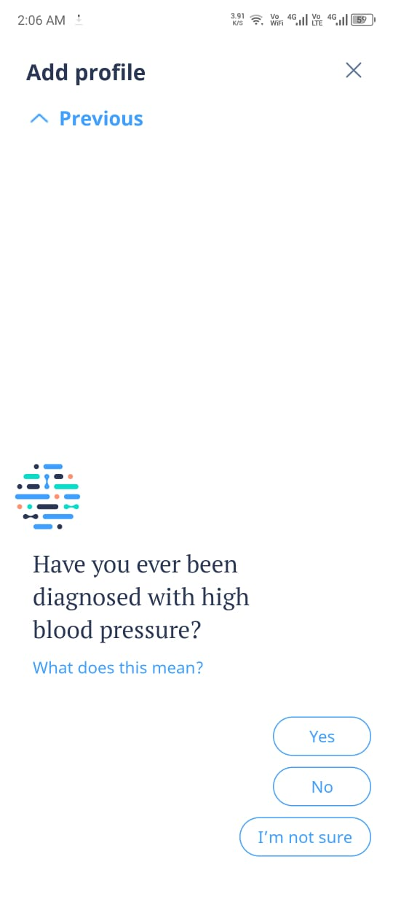
Figure 2.1. Interactive symptom & medical history questions

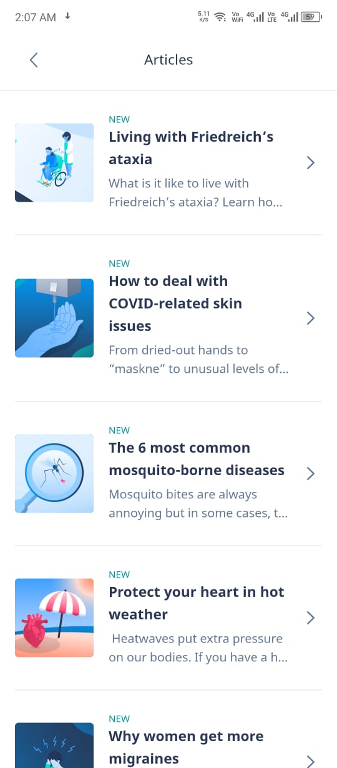
Figure 2.2. Personalized health articles & advice

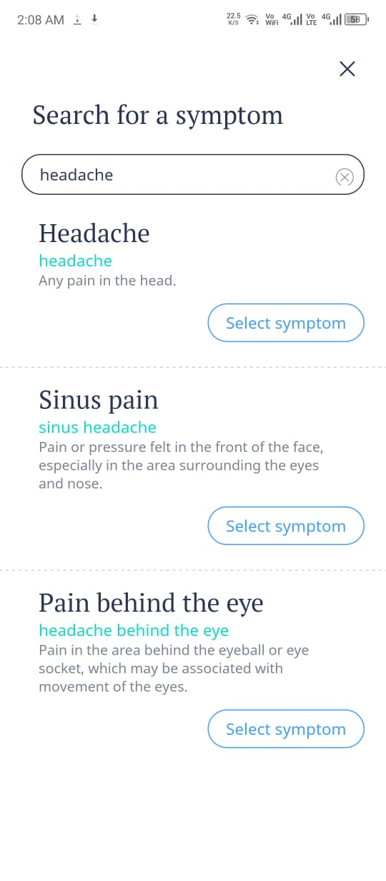
Figure 2.3. Symptom search and detailed selection

Technology Stack
- Artificial Intelligence and medical knowledge graphs
- Cloud-based backend infrastructure
- Mobile and web applications

User Interface & Experience
Ada Health offers a conversational, chatbot-like interface that guides users step-by-step. The structured questioning makes it easy for non-technical users to describe symptoms accurately.

Strengths
- High accuracy in symptom analysis
- Strong clinical validation
- Simple and engaging user interaction

Drawbacks/Limitations
- No direct doctor appointment booking
- No call-based or voice automation
- Limited integration with healthcare providers

Target Audience
Individuals seeking early symptom assessment and general health awareness.

Solution 2: Babylon Health

Overview
Babylon Health is an online health care provider that integrates telemedicine with AI symptom check [4]. It enables its users to evaluate their symptoms and visit licensed physicians via video or chat.

Key Features & Functions
- AI-powered symptom assessment
- Online doctor consultations
- Appointment scheduling and health records
- Health monitoring tools
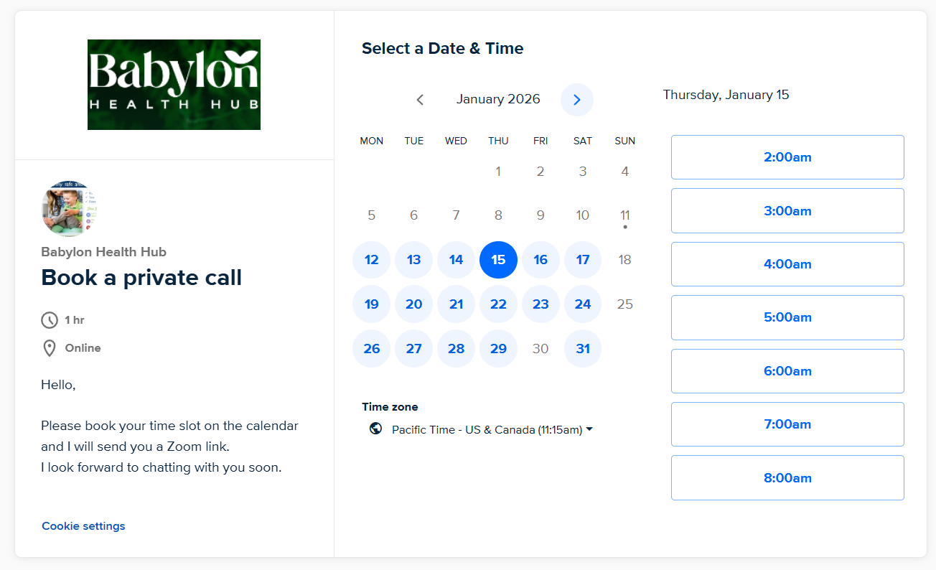
Figure 2.4. Online appointment scheduling with calendar and time zone selection

Figure 2.5. Programme booking for personalized family health coaching

Technology Stack
- AI and Natural Language Processing (NLP)
- Cloud-based microservices
- Mobile and web platforms

User Interface & Experience
The platform provides a professional and modern interface. However, some advanced features are locked behind paid subscriptions, which may affect accessibility.

Strengths
- Combines AI with real doctor consultations
- End-to-end digital healthcare experience
- Reliable and scalable infrastructure

Drawbacks / Limitations
- Subscription-based pricing
- Limited automation in doctor-side communication
- No intelligent call handling system

Target Audience
Users seeking online medical consultations and digital healthcare services.

Solution 3: WebMD

Overview
WebMD is a well-known web-based health information resource site that offers medical articles, descriptions of conditions, and symptom checker utilities [5]. It does not put a major emphasis on the direct healthcare services except in education.

Key Features & Functions
- Symptom checker
- Medical articles and condition guides
- Medication and treatment information
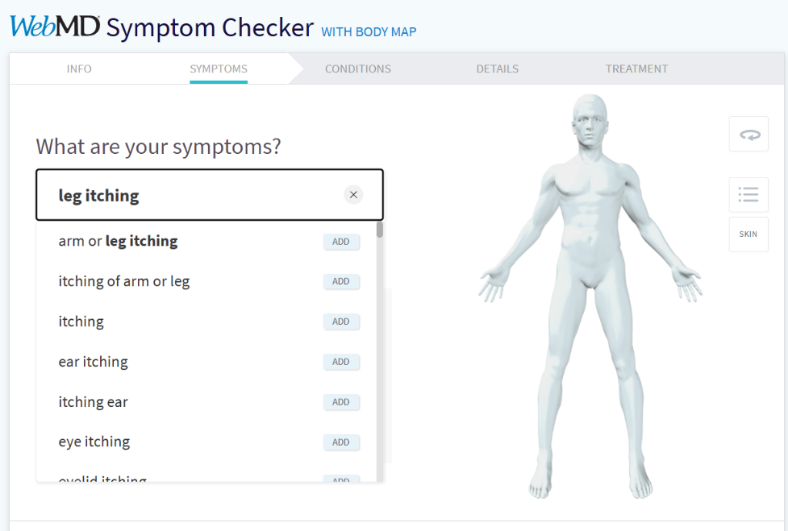
Figure 2.6. Symptom entry with search suggestions and interactive body map
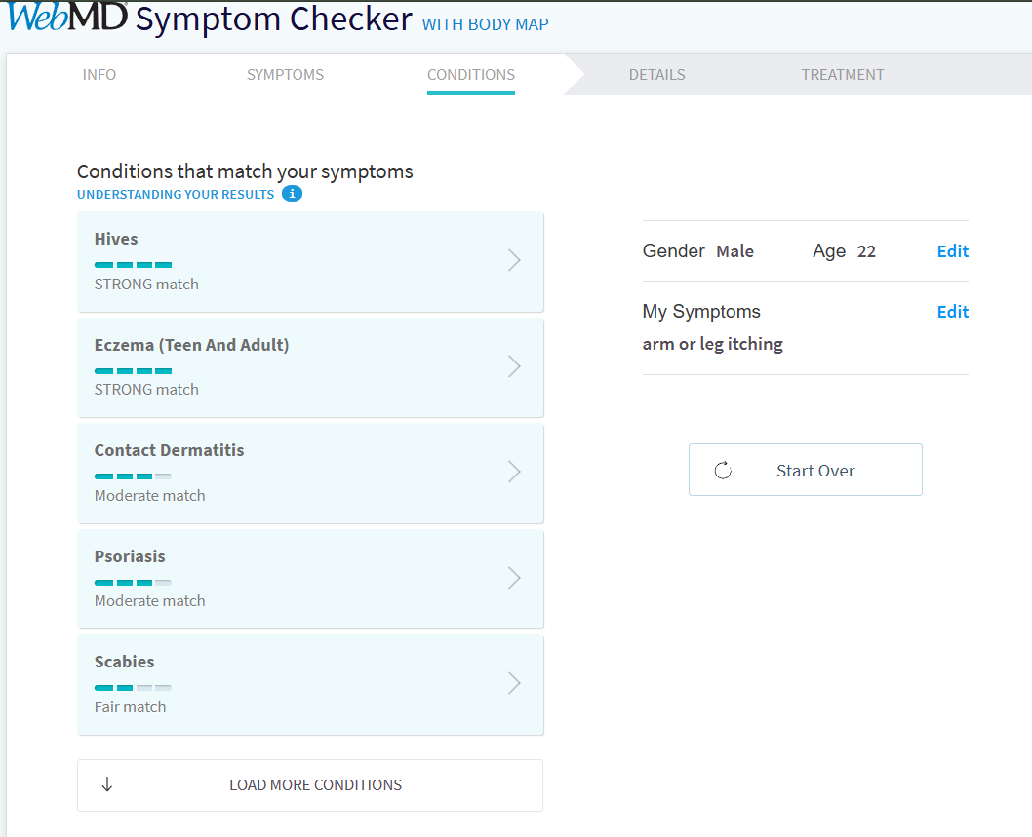
Figure 2.7. Potential condition suggestions with match ratings
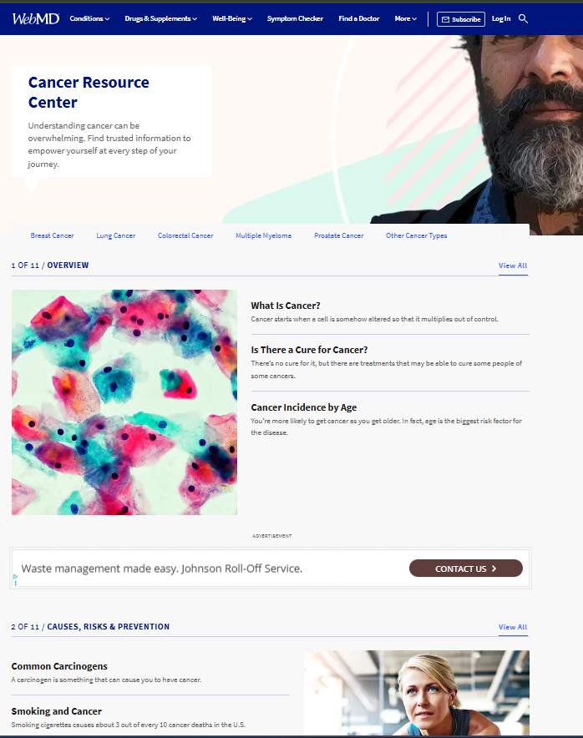
Figure 2.8. Medical articles, condition guides, and treatment details
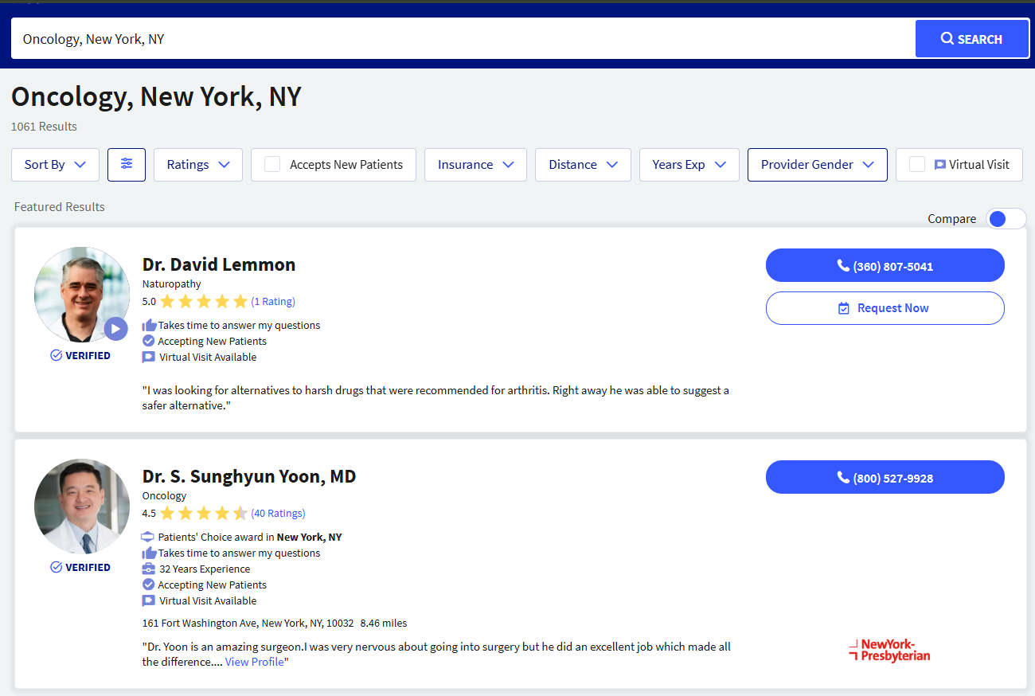
Figure 2.9. Physician directory with search filters, ratings, and virtual visit options

Technology Stack
- Web-based content management systems
- Cloud hosting and analytics tools

User Interface & Experience
WebMD offers a straightforward and information-centric interface. It is easy to navigate but lacks interactive or personalized healthcare features.

Strengths
- Trusted and well-researched medical content
- Large user base and credibility
- Free access to information

Drawbacks / Limitations
- No doctor recommendation system
- No appointment booking
- No conversational or AI-driven interaction

Target Audience
Users are looking for medical information and general health education.

Solution 4: Practo

Overview
Practo is a medical app that matches patients and doctors to clinics [6]. It deals with booking of appointments, physician search, and teleconsultation, particularly within the South Asian markets.

Key Features & Functions
- Doctor search by specialization and location
- Online appointment booking
- Teleconsultation services
- Patient reviews and ratings
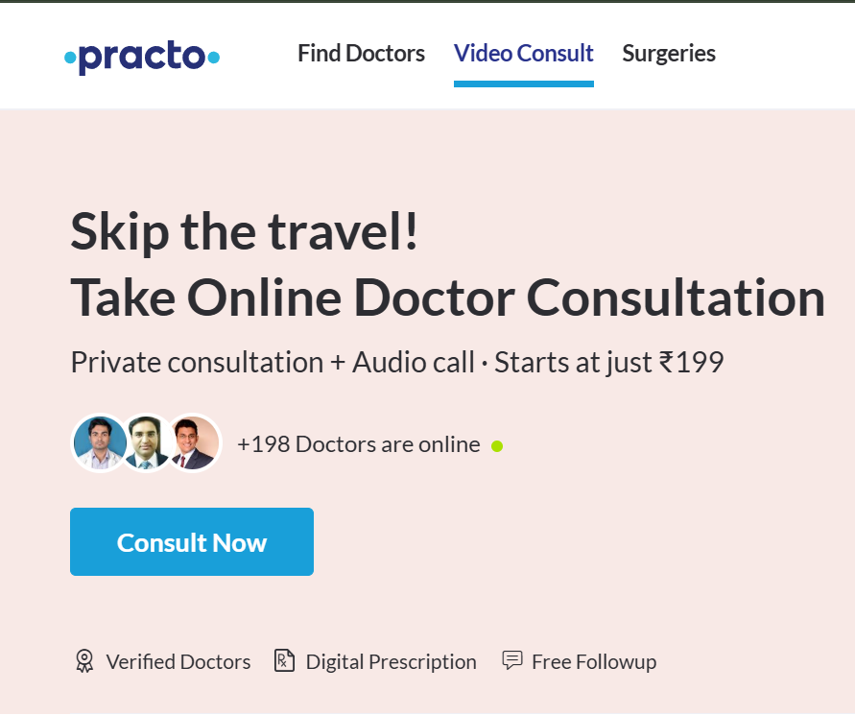
Figure 2.10. Online video/audio consultation promotion with instant doctor access and digital features
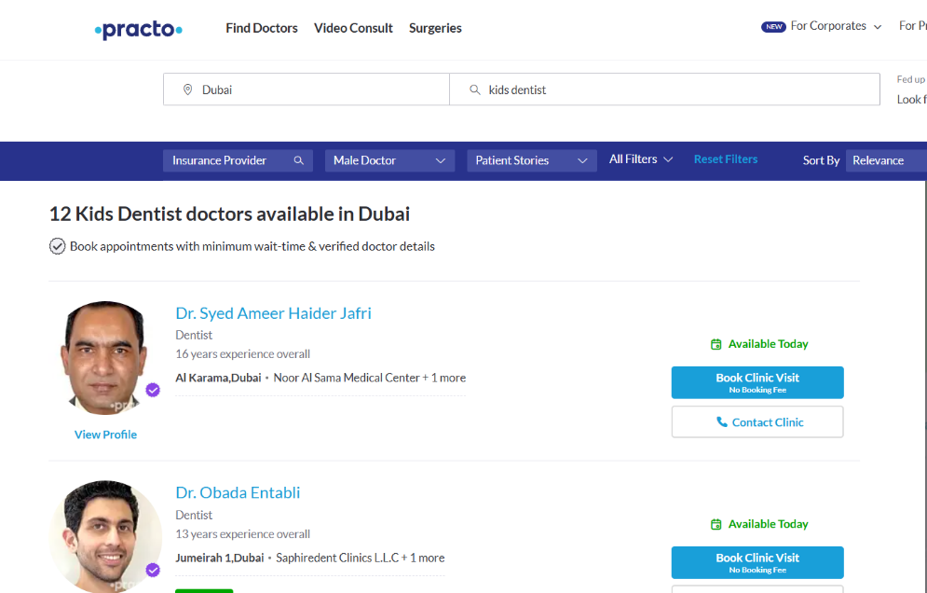
Figure 2.11. Location-based doctor search by specialization (e.g., kids dentist in Dubai) with filters and booking options

Technology Stack
- Web and mobile applications
- Cloud-based backend services
- Relational databases

User Interface & Experience
Practo provides a user-friendly interface with filters and search options, making it easy for users to find doctors quickly.

Strengths
- Strong doctor directory
- Efficient appointment scheduling
- Good market penetration

Drawbacks / Limitations
- No AI-based symptom analysis
- Heavy reliance on manual doctor interaction
- No call automation

Target Audience
Patients seeking doctors and appointment booking services.

Solution 5: Doctolib

Overview
Doctolib is a European healthcare appointment management and scheduling application, used by patients, clinics, and doctors [7]. It is aimed at streamlining medical timetables and decreasing the amount of work in the administration department.

Key Features & Functions
- Online appointment booking
- Doctor calendar and schedule management
- Automated appointment reminders
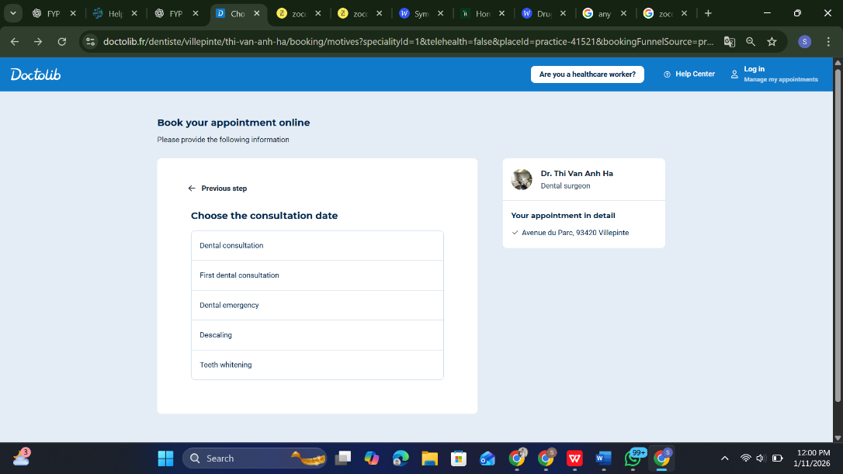
Figure 2.12. Online appointment booking interface with consultation type selection and real-time date availability
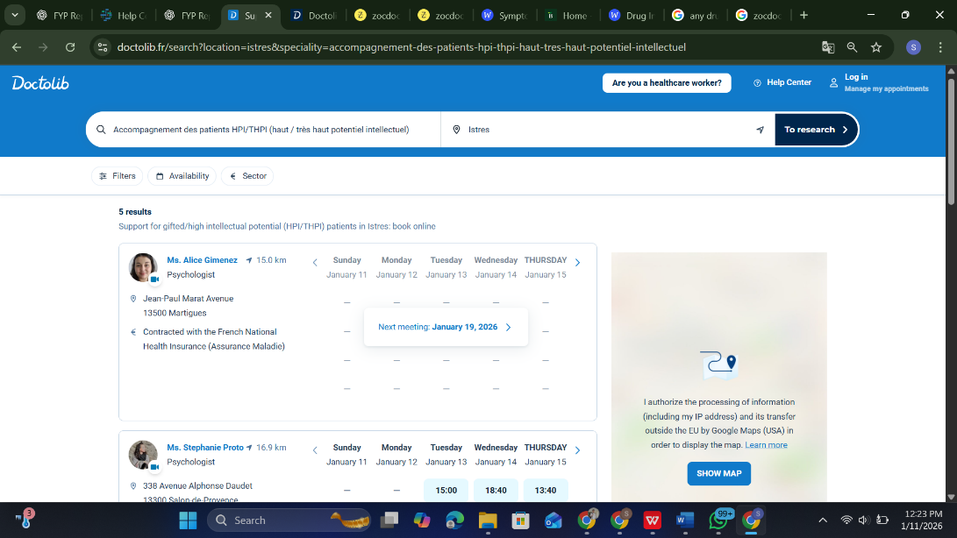
Figure 2.13. Advanced doctor search by specialty/location with calendar previews and availability slots

Technology Stack
- Cloud-based web applications
- Scheduling and notification systems

User Interface & Experience
The interface is clean, efficient, and optimized for quick appointment booking, but lacks intelligent patient interaction features.

Strengths
- Efficient scheduling system
- Strong adoption by healthcare providers
- Reduces administrative overhead

Drawbacks / Limitations
- No symptom assessment
- No AI chatbot or voice automation
- Limited patient guidance

Target Audience
Patients and clinics requiring appointment management solutions

Solution 7: Marham

Overview
Marham is a Pakistani digital healthcare and telemedicine platform that connects patients and verified doctors to find specialists, book appointments, and conduct online consultations [8]. It was established in 2015 and has since become one of the biggest healthcare networks in the country that helps millions of users and thousands of medical professionals with the help of its webpage and phone app.

Key Features & Functions
- Search and find doctors by specialty, location, or name
- Online booking of physical or virtual consultations
- Audio and video consultations with doctors
- Doctor profiles with qualifications, reviews, and availability
- Health forums and question-and-answer sections
- Integrated maps for clinic locations
- Feedback and ratings for doctors by users
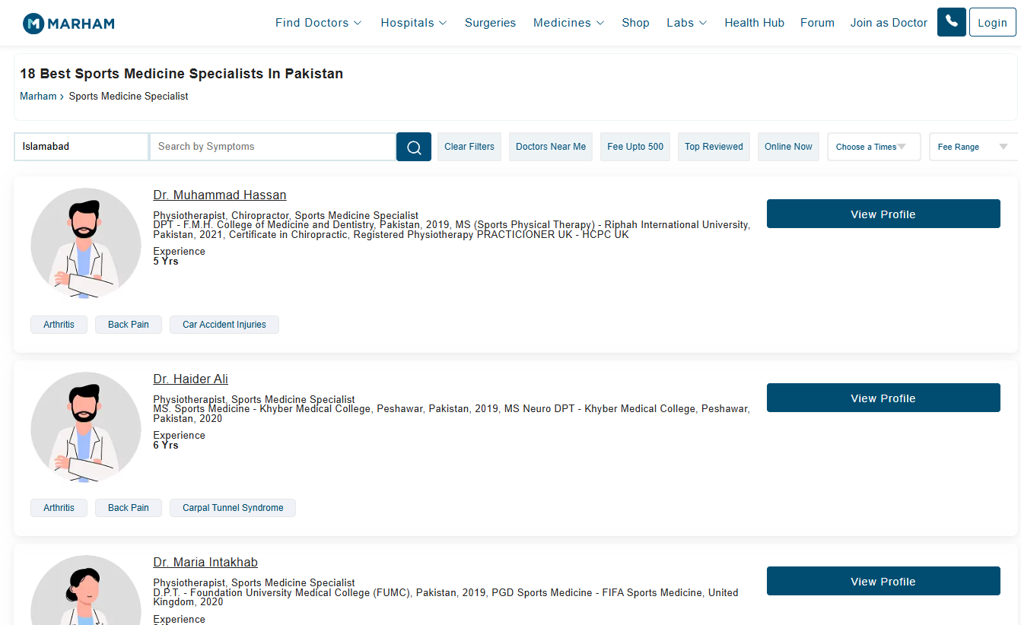
Figure 2.14. Doctor discovery feature on Marham for finding sports medicine specialists
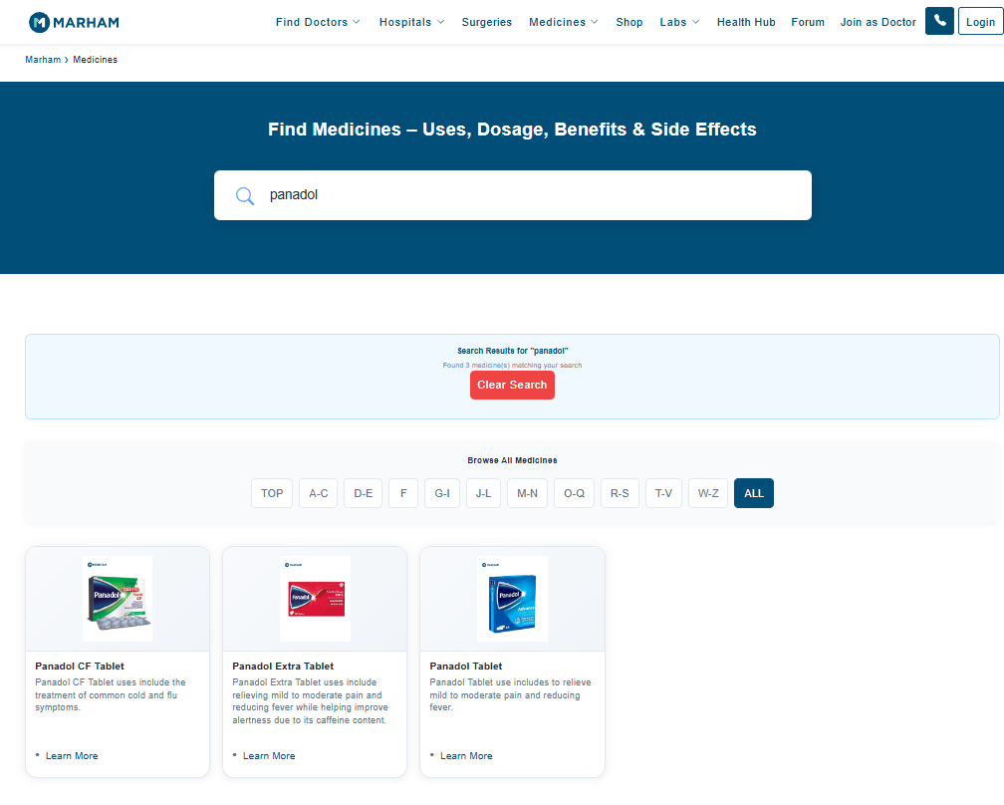
Figure 2.15. The medicine search feature on Marham shows available Panadol options

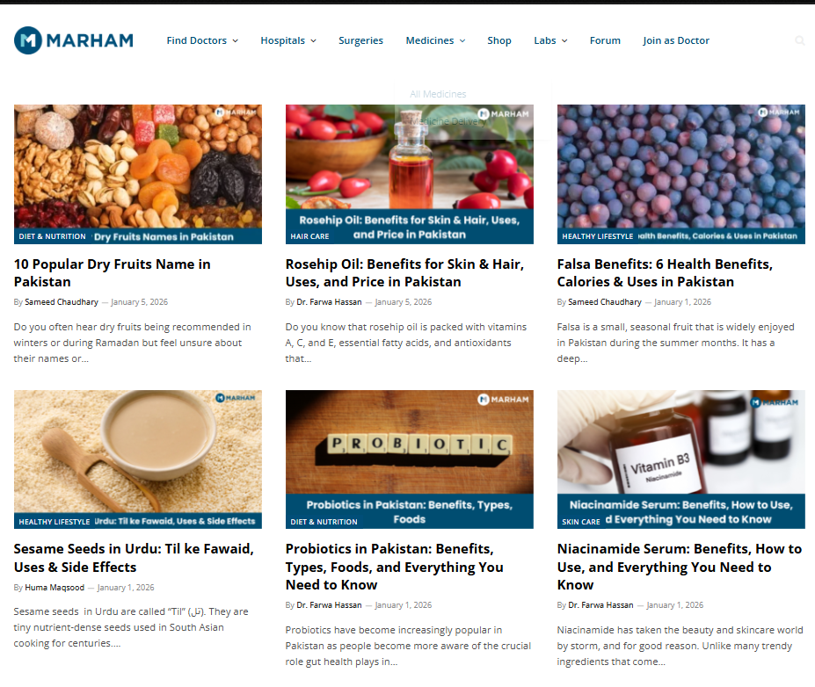
Figure 2.16. Health articles and wellness information feature on Marham, providing diet, nutrition, skincare, and lifestyle guidance.
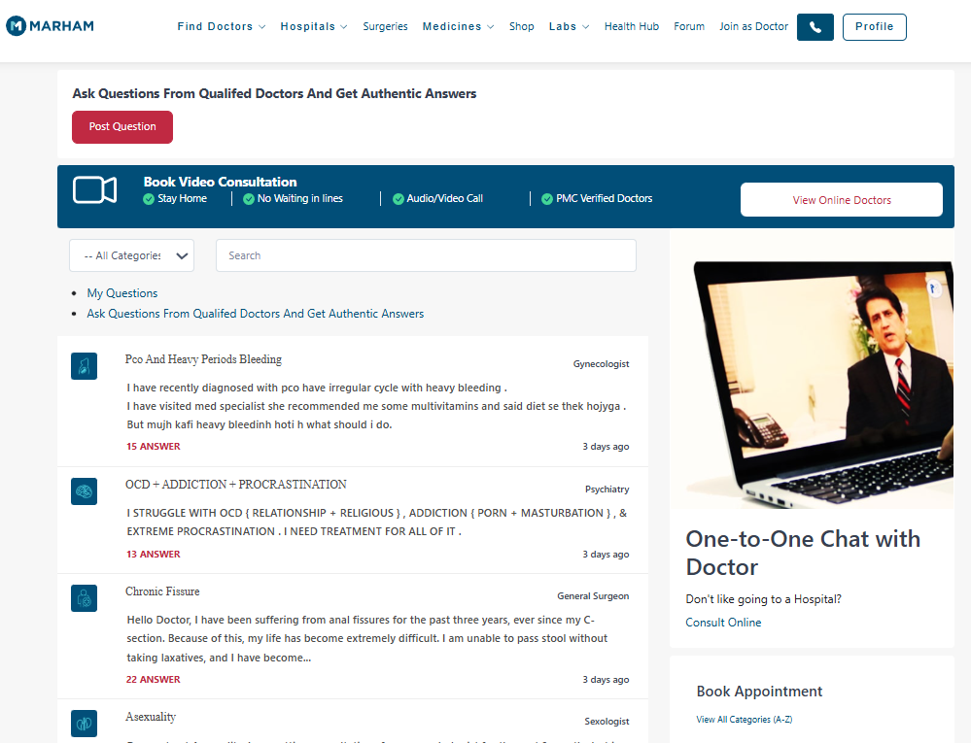
Figure 2.17. Ask Pakistani doctors real questions & consult online from home

Technology Stack
- Web platform with responsive user interface
- Mobile applications for Android and iOS
- Cloud-hosted backend services supporting search, scheduling, and telemedicine
- Integrated scheduling and notification systems (appointment management through database and web services)

User Interface & Experience
Marham’s interface is designed for ease of use, with clear menus to find doctors, view profiles, and book appointments. The mobile app allows filtering by speciality, fee range, and city. User reviews and ratings are displayed within doctor profiles to help patients make informed choices. The forum and Q&A sections engage users in broader healthcare discussions.

Strengths
- Wide network of registered doctors and medical specialties
- Both in-person and online consultation booking available
- Audio/video consultation features increase accessibility
- Integrated maps and feedback improve the search experience
- Large user base and extensive doctor directory

Drawbacks / Limitations
- Reported user dissatisfaction and service issues have been highlighted in reviews, including appointment confirmation issues and customer support challenges.
- Limited AI automation, the user still navigates doctor listings rather than conversational AI for symptom analysis.
- Does not provide intelligent symptom assessment or proactive health recommendations.
- Appointment reliability may vary depending on the doctor's availability and platform follow-up.

Target Audience
- Patients in Pakistan seeking verified doctors and online consultations
- Users needing both remote and clinic appointments
- Healthcare consumers who prefer browsing expert profiles before booking

Comparative Analysis Table
Table 2.1. Comparative analysis of existing digital healthcare platforms
Product Name | Key Features | Technology Used | Pricing Model | Pros & Cons
Ada Health | Symptom checker | AI, Cloud | Free/Paid | Accurate, but no doctor automation
Babylon Health | Symptom check, telemedicine | AI, NLP | Subscription | Comprehensive but costly
WebMD | Health info, symptom checker | Web CMS | Free | Informative but no interaction
Practo | Doctor search, booking | Web, Cloud | Freemium | Good booking, no AI
Doctolib | Appointment scheduling | Cloud-based | Subscription | Efficient scheduling, limited intelligence
Marham | Online consultation, doctor booking, health articles | Web, Mobile, Cloud | Freemium | Good local doctors, limited AI features

Identified Gaps & Project Justification
The analysis shows that existing solutions either focus on symptom checking or doctor discovery and appointment scheduling, but none provide a fully integrated system combining conversational AI, intelligent symptom analysis, personalized doctor recommendations, and automated doctor-side call handling. Additionally, voice-based automation for managing patient calls is largely absent.
The proposed AI-Powered Virtual Medical Assistant and Smart Doctor Calling Agent addresses these gaps by integrating AI chatbot interaction, machine learning-based symptom analysis, automated appointment management, and smart call handling into a single platform. This unified approach improves efficiency, reduces administrative workload, and enhances patient–doctor communication, making it a strong justification for the proposed project.

Requirement Analysis

Stakeholders List
Stakeholders refer to persons and entities with a direct/indirect interest in the development and utilization of the proposed system [9]. Determining the stakeholders assists in ensuring that the requirements of the system are according to the needs and expectations of the stakeholders. The key stakeholders involved in this project are listed below:
- Patients: End users who interact with the AI chatbot to describe symptoms, receive medical guidance, and obtain doctor recommendations.
- Doctors and their assistants: Healthcare professionals who receive patient calls, appointment requests, and inquiries through the smart calling agent.
- Clinic Administrators: Individuals responsible for overseeing appointment management and operational efficiency.
- System Developers: The project team responsible for designing, implementing, testing, and maintaining the system.
- Project Supervisor: Provides academic guidance, evaluation, and oversight throughout the project lifecycle.
- API Service Providers: Third-party services such as OpenAI and Retell that enable conversational and voice-based AI functionality.

Requirements Elicitation
Requirements elicitation is the task that entails the act of analyzing and articulating the system requirements about the needs of the stakeholders and project goals [10]. In this project, the identification of the requirements was performed with the help of various methods, namely the study of the existing healthcare platforms, reviewing the main research publications, brainstorming with the team members, and discussing with the main users. User requirements were assessed from both the patient and doctor points of view in order to ensure that the system is able to facilitate smart interaction, automation, and usability. The requirements elicited were broken down into system design and implementation by grouping them into functional and non-functional requirements.

Functional Requirements
The functional requirements describe what the system is expected to do [11]. The key functional requirements of the proposed system are as follows:
- The system shall allow patients to interact with the virtual medical assistant using natural language text input.
- The system shall analyze patient-reported symptoms using machine learning techniques.
- The system shall suggest possible medical conditions based on symptom analysis.
- The system shall recommend appropriate doctors based on medical specialization and user location.
- The system shall allow patients to view doctor details, including name, specialization, and contact information.
- The system shall automate doctor-side call handling using a smart calling agent.
- The system shall schedule, modify, and cancel appointments automatically.
- The system shall maintain logs of chatbot interactions, calls, and appointments.
- The system shall provide doctors with access to call logs and appointment details.

Non-functional Requirements
Non-functional requirements define the quality attributes and constraints of the system [11]. The key non-functional requirements include:
- Usability: The system shall provide a user-friendly and intuitive interface for both patients and doctors.
- Performance: The system shall respond to user queries within an acceptable time frame.
- Scalability: The system shall support an increasing number of users without performance degradation.
- Security: Patient data shall be securely stored and protected against unauthorized access.
- Reliability: The system shall ensure consistent operation and minimal downtime.
- Availability: The system shall be accessible to users through web-based platforms.
- Maintainability: The system shall be modular and easy to update or extend.

Requirements Traceability Matrix
The Requirements Traceability Matrix (RTM) is valuable to make sure that all the requirements are allocated to system goals and are verified in the process of implementation and testing [12].
Table 3.1. Requirements Traceability Matrix
Requirement ID | Requirement Description | Objective Reference | Validation Method
FR-01 | Patient chatbot interaction | Obj-1 | Functional Testing
FR-02 | Symptom analysis using ML | Obj-1 | Model Evaluation
FR-03 | Doctor recommendation | Obj-2 | System Testing
FR-04 | Automated call handling | Obj-3 | Integration Testing
FR-05 | Appointment management | Obj-3 | User Acceptance Testing
NFR-01 | Usability | Obj-4 | User Feedback
NFR-02 | Security | Obj-4 | Security Review

Use Case Description
A use case describes how an actor interacts with the system to achieve a specific goal. One of the primary use cases of the system is described below:
Use Case Name: Patient Symptom Analysis and Doctor Recommendation
Actor: Patient
Preconditions: Patient has internet access and system availability
Main Flow:
- The patient opens the web application.
- The patient enters symptoms in natural language.
- The system analyzes symptoms using the AI model.
- The system identifies possible medical conditions.
- The system recommends suitable doctors based on specialization and location.
- The patient views the doctor's details and appointment options.
Postconditions: Patient receives medical guidance and doctor recommendations.
Alternate Flow: If insufficient or unclear symptoms are provided, the system prompts the patient for additional information.

System Constraints and Assumptions
The system is limited by the reliance on third-party APIs like OpenAI and Retell, which demand consistent access to the internet and the acceptance of usage restrictions. The academic project duration is also a constraint on the scale of deployment, given time and resource constraints. Assumptions made are that the users will present the correct information regarding symptoms and that the healthcare providers will collaborate with the system. Also, the system does not substitute professional medical diagnosis and functions in the form of a preliminary assistance tool.

System Design
This chapter describes the overall design of the Virtual Medical Assistant and Smart Doctor Calling Agent, powered by AI. The system design phase represents and refines the specifications of the system requirements found in Chapter 3 into a system representation that is both structured and visual. The design is based on scaling, modularity, and maintainability, as well as intelligent automation and real-time communication.

Use Case Design
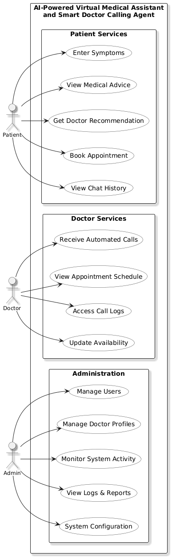
Figure 4.1. Use Case Diagram of the AI-Powered Virtual Medical Assistant System

Description:
Figure 4.1 Use Case Diagram depicts the functional communication between the system and other external actors, i.e., Patient, Doctor, and Admin. It gives the user a detailed outline of what the system can do on a high level. The system interacts with the patients in terms of symptom input, medical advice, doctor recommendations, and appointment booking. Doctors receive the system to handle automated calls, consultations on appointments, and update the availability. Admin actor manages users, monitors activities inside the system, and sets the system settings. This diagram assists in defining the boundaries of the system and also specifically specifying the roles and contributions of each actor.

Activity Diagram
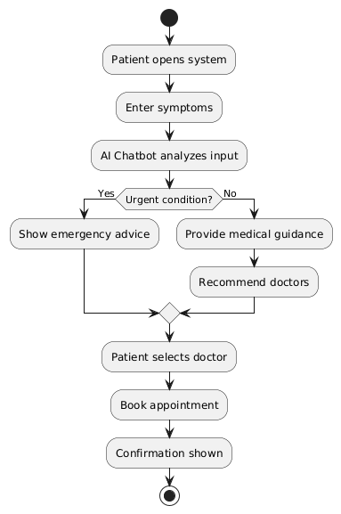
Figure 4.2. Activity Diagram representing patient and doctor interactions

Description:
Figure 4.2 Activity Diagram shows the steps of the process of a patient and the AI medical assistant. It demonstrates the flow of the activities beginning with the process of symptom entry, the analysis of the data using AI, the urgency decision-making, the recommendation of doctors, and the process of booking an appointment. Various outcomes are coded in conditional flows, including urgent and non-urgent medical conditions. This diagram reflects the control flow of the system and assists in conceptualizing the logical flow of activities of an interaction with a patient.

Sequence Diagram
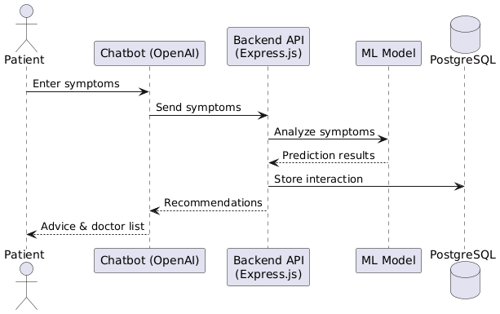
Figure 4.3. Sequence Diagram illustrating symptom analysis and doctor recommendation workflow
Description:
Figure 4.3 Sequence Diagram shows how the system components communicate with one another in order of time when analyzing the symptoms and the doctor's prescription. It displays the way in which the patient interacts with the chatbot, which sends the request to the backend API. The backend communicates with the machine learning model and saves the data of interaction in the database. The outcomes are then provided back to the patient in terms of medical recommendations and are prescribed by physicians. This figure gives a clear description of the dynamic behavior of the system and the flow of communication within various modules.

Software Architecture Diagram
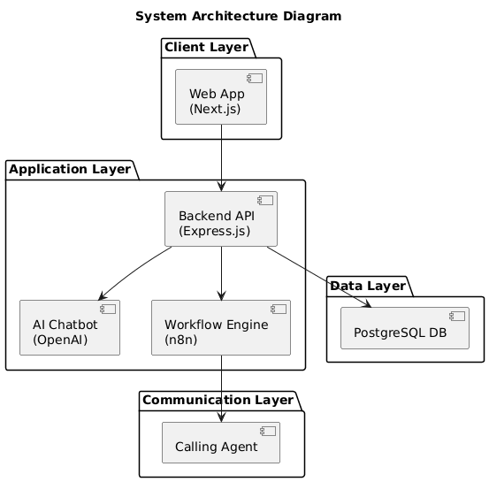
Figure 4.4. Software Architecture Diagram of the AI-Powered Medical Assistant System
Description:
Figure 4.4 Software Architecture Diagram is the high-level structural organization of the system created in layers-based architecture manner. The client side will be a web-based frontend that will be built with Next.js. Application layer comprises the backend API (express.js), AI chatbot (OpenAI), and the workflow automation engine (n8n). The data layer will consist of a PostgreSQL database that will be used for persistent storage. The Retell call agent is built into the communication layer to facilitate automated doctor calls. This architecture is modular, scalable, and provides efficient component integration.

Class Diagram
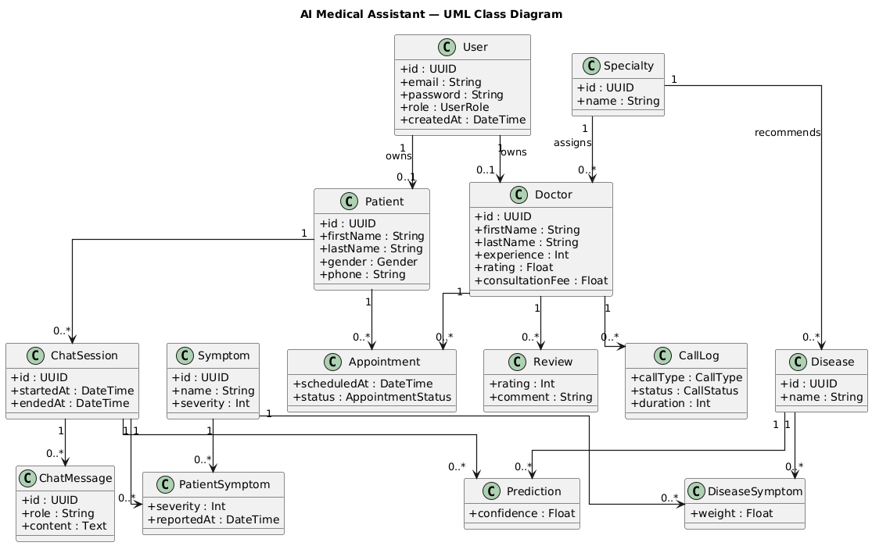
Figure 4.5. Class Diagram showing system entities and relationships
Description:
Figure 4.5 Class Diagram gives a static picture of the system that models the main classes, their attributes, and the relationships. It characterizes fundamental objects like User, Patient, Doctor, Admin, Appointment, and ChatSession. Different user roles, which are based on a base User class, are depicted as inheritance relationships. Connections among patients, physicians, and appointments are a manifestation of real-world interactions. The diagram facilitates the interpretation of the system object-oriented pattern and forms a basis for implementation and database design.

Database Diagram
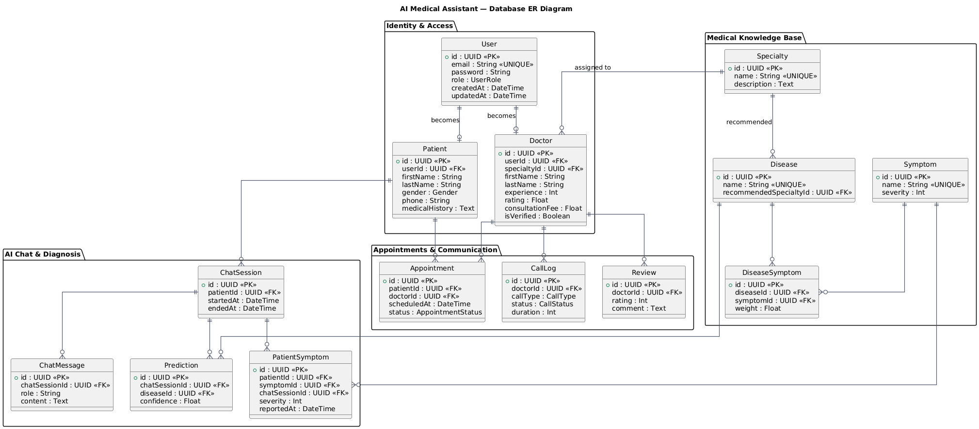
Figure 4.6. Database (ER) Diagram of the Medical Assistant System
Description:
Figure 4.6 Database (ER) Diagram shows the format of the relational database to be used in the system. It specifies the identities of users, patients, doctors, appointments, and chat logs with their attributes and relationships that exist between them. In the relationships, there is a primary key relationship and a foreign key relationship that guarantee data integrity and normalization. This schema gives a visual description of the process of data storage, connectivity, and control in the PostgreSQL database, which makes it easy to query the data and protect the information held.

Collaboration Diagram
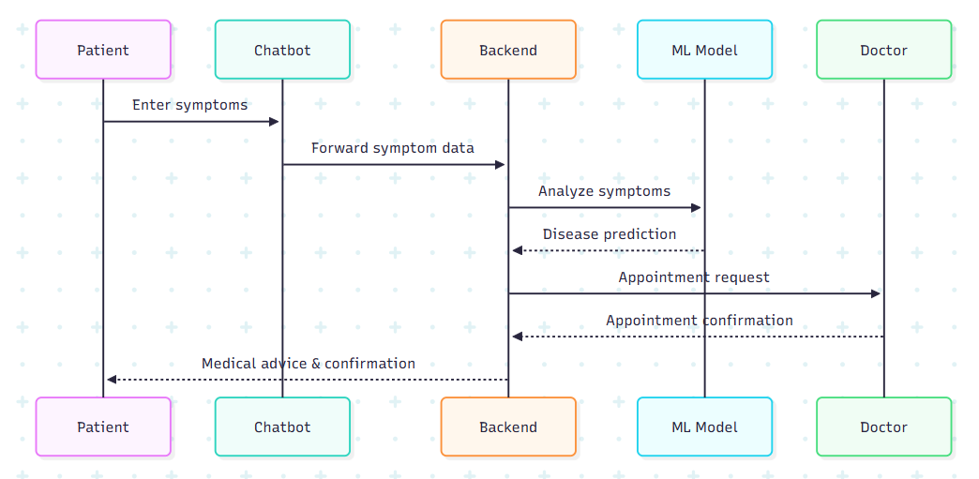
Figure 4.7. Collaboration Diagram showing interaction between system components
Description:
Figure 4.7 A Collaboration Diagram illustrates the relationship between various components of a system with each other to accomplish a certain functionality and gives emphasis on the communication with others as opposed to position. It underlines the connection between the patient, chatbot, backend system, machine learning model, and doctor during the process of consultation and appointment. This diagram highlights collaboration between system items and assists in the manner in which roles are shared among the components in an attempt to provide the targeted functionality.

References
[1] M. A. Rahman, E. Victoros, J. Ernest, R. Davis, Y. Shanjana, and M. R. Islam, "Impact of artificial intelligence (AI) technology in healthcare sector: a critical evaluation of both sides of the coin," Clinical Pathology, vol. 17, p. 2632010X241226887, 2024.
[2] A. Haleem, M. Javaid, R. P. Singh, and R. Suman, "Telemedicine for healthcare: Capabilities, features, barriers, and applications," Sensors international, vol. 2, p. 100117, 2021.
[3] Ada. "Health Powered by Ada." Ada. https://ada.com/ (accessed 7-Jan-2026.
[4] B. H. Hub. "Take control of your health at Babylon Health Hub." Babylon Health Hub. https://babylonhealthhub.com/ (accessed 7-Jan-2026.
[5] WebMD. "WebMD Symptom Checker WITH BODY MAP." WebMD. https://www.webmd.com/ (accessed 7-Jan-2026.
[6] Practo. "Book Doctor Appointments Online, Order Medicine, Diagnostic Tests, Consult." Practo. https://www.practo.com/ (accessed 7-Jan-2026.
[7] Doctolib. "Doctolib: Book an appointment online with a healthcare professional." Doctolib. https://www.doctolib.fr/ (accessed 7-Jan-2026.
[8] Marham. "Marham: Find A Doctor, Book Appointment or Consult Online." https://www.marham.pk/ (accessed 7-Jan-2026.
[9] J. Fernando. "Stakeholders: Definition, Types, and Examples." Investopedia. https://www.investopedia.com/terms/s/stakeholder.asp (accessed 7-Jan-2026.
[10] M. J. Ryan, "1.2. 2 the role of stakeholders in requirements elicitation," in INCOSE International Symposium, 2014, vol. 24, no. 1: Wiley Online Library, pp. 16-26.
[11] Geeksforgeeks. "Functional and Non-Functional Requirements." Geeksforgeeks. https://www.geeksforgeeks.org/software-engineering/functional-vs-non-functional-requirements/ (accessed 7-Jan-2026.
[12] R. C. Fries and A. E. Bloesch, "Medical device software development," Biomedical Engineering e-Mega Reference, p. 453, 2009.

Appendix A
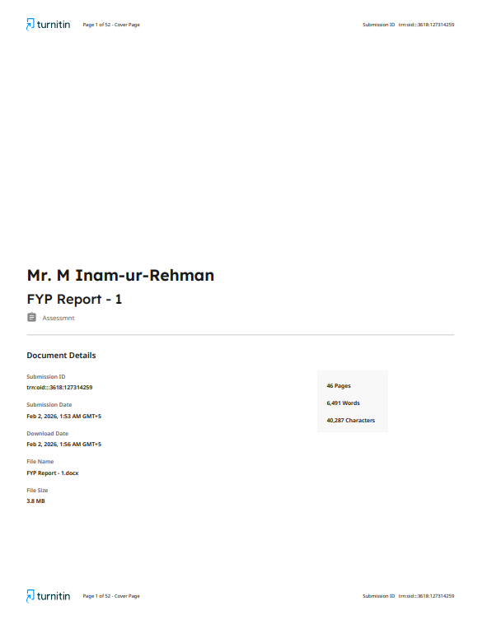
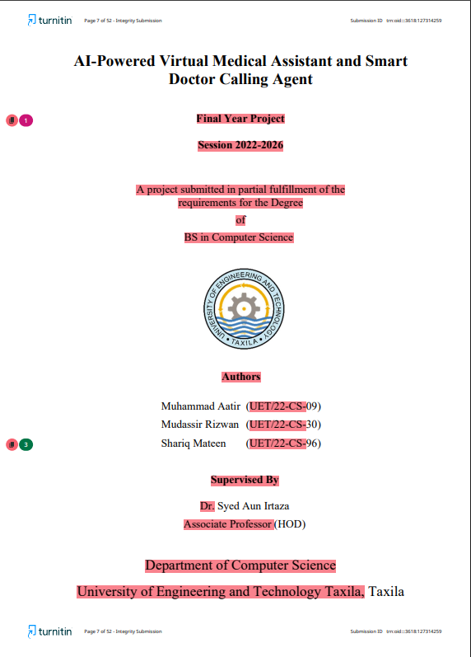
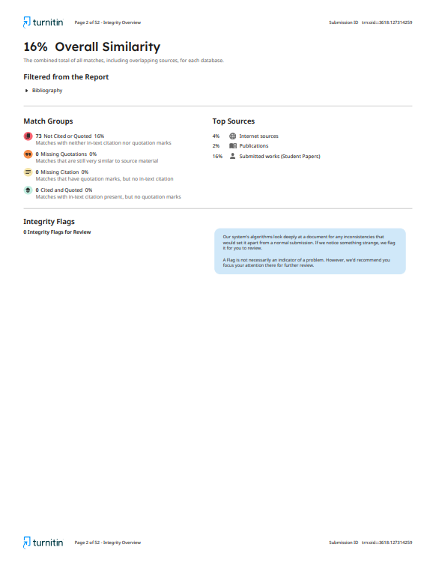

Appendix B
